**Automated Partition Management for Analysis Services Tabular Models**

**Microsoft BI Technical Article**

**Writer:** Christian Wade, Senior Program Manager, Microsoft Corp.

**Contributor:** Owen Duncan, Senior Content Developer, Microsoft Corp.

**Published:** January 2017

**Applies to:** Microsoft SQL Server 2016 Analysis Services, Microsoft Azure Analysis Services

**Summary:** This whitepaper and associated samples describe partition management automation by using the Tabular Object Model (TOM).

**Copyright**

This document and associated samples are provided as-is. Information and views expressed in this document, including URL and other Internet Web site references, may change without notice. You bear the risk of using it.

Some examples depicted herein are provided for illustration only and are fictitious.  No real association or connection is intended or should be inferred.

This document does not provide you with any legal rights to any intellectual property in any Microsoft product. You may copy and use this document for your internal, reference purposes.

© 2016 Microsoft. All rights reserved

Contents

Introduction 3

Partitioning Strategy & Assumptions 3

Rolling-window pattern 3

Partition granularity 3

Mixed granularity 4

Parallelization 4

Online & offline processing 4

Non-partitioned table processing 4

Table omission 4

Configuration & logging database 4

Date key format 4

Getting Started 5

Requirements 5

AsPartitionProcessing solution 5

AdventureWorks 5

SampleClient 5

Configuration & Logging Database 8

Data model 8

ModelConfiguration 8

TableConfiguration 9

PartitioningConfiguration 9

ProcessingLog 10

Sample Configuration 10

Database connection info 11

Test Different Configurations 11

Incremental mode 12

Increment partition range 13

Offline processing 14

Non-partitioned table processing & table omission 15

Merging partitions 16

Mixed granularity configurations 17

Validation of date ranges for mixed granularity configurations 19

Other Considerations 20

Cloud architecture 20

Custom logging 21

Fragmentation 21

Locking and blocking 22

Parallelization of incremental processing 23

Model deployment 23

AsPerfMon 24

# Introduction

Analysis Services tabular models can store data in a highly-compressed, in-memory cache for optimized query performance. This provides fast user interactivity over large data sets.

Large datasets normally require table partitioning to accelerate and optimize the data-load process. Partitioning enables incremental loads, increases parallelization, and reduces memory consumption. The [Tabular Object Model](https://msdn.microsoft.com/en-us/library/microsoft.analysisservices.tabular.aspx) (TOM) serves as an API to create and manage partitions. TOM was released with SQL Server 2016 and is discussed in more detail [here](https://technet.microsoft.com/en-us/library/mt712541.aspx). Model Compatibility Level 1200 or above is required.

This document describes how to use the [AsPartitionProcessing](https://github.com/Microsoft/Analysis-Services/tree/master/AsPartitionProcessing) TOM code sample for automated partition management.

The sample,

* Is intended to be generic and configuration driven.
* Works for both Azure Analysis Services and SQL Server Analysis Services tabular models.
* Can be leveraged in many ways including from an SSIS script task, Azure Functions and others.

**Note**: Loading data into the in-memory cache is often referred to as *processing*. This terminology is used by this document.

# Partitioning Strategy & Assumptions

## Rolling-window pattern

AsPartitionProcessing follows the rolling-window pattern, which is common in traditional Analysis Services implementations. The data is kept within a predefined date range and incremented as necessary. This maintains memory usage within a predictable range over time.

## Partition granularity

Yearly, monthly and daily partition granularities can be configured. Choice of granularity is influenced by various factors including how much data is required to be incrementally refreshed and how much processing time is acceptable. For example, if only the last 3 days need to be refreshed daily, it may be beneficial to use daily granularity.

## Mixed granularity

Mixed granularity for a table can also be configured for scenarios such as near-real time refresh at low grain coupled with historical, static partitions at higher granularity. This results in fewer partitions for a table, but also increases management overhead to ensure partition ranges are defined correctly. Unless there are hundreds of partitions or more, there is normally no significant query-performance penalty resulting from keeping the partitions at the lowest grain.

## Parallelization

Initial setup processing is sequential. Incremental processing can be performed in parallel.

Initial setup will create and process the partitions for the first time based on the configuration. This is performed one partition at a time to limit memory consumption (data is not fully compressed during processing). For a large data set, the initial load may typically take a few hours depending on factors such as the query performance of the source system.

Incremental processing is submitted as a parallelized operation for all tables and partitions within a model.

## Online & offline processing

Incremental processing can be performed as an online operation, or offline for less memory usage; it is configuration driven. Online incremental processing requires a copy of the data to be maintained in memory for queries until the new data is ready, and then switches to the new data. When processing multiple tables, keeping the model online can be less efficient because it often requires recalculation of the same calculated columns, relationships and indexes multiple times. Offline processing has the benefit of performing this recalculation just once at the end of the processing window.

## Non-partitioned table processing

The sample can be configured to process non-partitioned tables in addition to partitioned ones. This avoids having to set up a separate process to refresh non-partitioned tables.

## Table omission

It is possible to configure that some tables in the model are not refreshed at all during normal incremental processing. Tables that may not require frequent processing often include the date dimension, categorical dimensions, and facts that may be defined annually such as budget.

## Configuration & logging database

Traditional Analysis Services implementations that require partitioning often use a configuration and logging database. AsPartitionProcessing is meant to work in this way, although this is optional. It can be set up to log messages to other targets. This enables easy partition configuration, and diagnosis of issues resulting from automated processing operations.

## Date key format

Date keys in source table are assumed to be integers formatted as yyyymmdd for partitioned processing. This format is commonly used for data warehouses and marts. If this is not available, it should be possible to derive such a column in a database view.

# Getting Started

## Requirements

Before you get started, you’ll need these tools:

**SQL Server 2016 with latest service pack** - Install the database engine and SSAS in tabular mode. You can download and install the free SQL Server 2016 Developer Edition [here](https://www.microsoft.com/en-us/sql-server/sql-server-editions-developers).

**SQL Server Data Tools** – Download and install the latest version [here](https://msdn.microsoft.com/en-us/library/mt204009.aspx).

**SQL Server Management Studio** - Download and install the latest version [here](https://msdn.microsoft.com/en-us/library/mt238290.aspx).

**Visual Studio 2015** – Download and install the free Community Edition [here](https://www.visualstudio.com/vs/community/).

## AsPartitionProcessing solution

Get the AsPartitionProcessing solution [here](https://github.com/Microsoft/Analysis-Services/tree/master/AsPartitionProcessing).

1. Open the solution in Visual Studio and build the project. The hint path for the client library DLLs is the following (assuming installation is on C:\ drive):

C:\Program Files (x86)\Microsoft SQL Server\130\SDK\Assemblies

1. Ensure AsPartitionProcessing.SampleClient is set as the startup project.

## AdventureWorks

The quickest way to understand the code sample is to run it on the AdventureWorksDW sample database. The backup file, AdventureWorksDW.bak, is included in the solution.

The tabular project, AsPartitionProcessing.AdventureWorks**,** is also provided in the solution. It should be used instead of the version from CodePlex because partitioning has been removed from the Internet Sales and Reseller Sales tables. Instead, these tables each have a single partition with the same name as the table, which is the default when you create a new table in SSDT. This partition acts as the *template partition* used by the AsPartitionProcessing sample.

Deploy and process the AdventureWorks tabular model.

## SampleClient

AsPartitionProcessing.SampleClient is a console application with a reference to the AsPartitionProcessing class library. It can easily be converted to work for customer projects. Alternatively, it provides sample client code to execute from an SSIS package, Azure Function, or other mechanism.

In Program.cs, note the ExecutionMode constant.

const SampleExecutionMode ExecutionMode = SampleExecutionMode.InitializeInline;

This means the InitializeAdventureWorksInline method will be executed to initialize parameters.

ModelConfiguration partitionedModel = new ModelConfiguration(

    modelConfigurationID: 1,

    analysisServicesServer: "localhost",

    analysisServicesDatabase: "AdventureWorks",

    initialSetUp: true,

    incrementalOnline: true,

    integratedAuth: true,

    userName: "",

    password: "",

    maxParallelism: -1,

    commitTimeout: -1,

    tableConfigurations:

    new List<TableConfiguration>

    {

        new TableConfiguration(

            tableConfigurationID: 1,

            analysisServicesTable: "Internet Sales",

            partitioningConfigurations:

            new List<PartitioningConfiguration>

            {

                new PartitioningConfiguration(

                    partitioningConfigurationID: 1,

                    granularity: Granularity.Monthly,

                    numberOfPartitionsFull: 12,

                    numberOfPartitionsForIncrementalProcess: 3,

                    maxDate: Convert.ToDateTime("2012-12-01"),

                    sourceTableName: "[dbo].[FactInternetSales]",

                    sourcePartitionColumn: "OrderDateKey"

                )

            }

        ),

        new TableConfiguration(

            tableConfigurationID: 2,

            analysisServicesTable: "Reseller Sales",

            partitioningConfigurations:

            new List<PartitioningConfiguration>

            {

                new PartitioningConfiguration(

                    partitioningConfigurationID: 2,

                    granularity: Granularity.Yearly,

                    numberOfPartitionsFull: 3,

                    numberOfPartitionsForIncrementalProcess: 1,

                    maxDate: Convert.ToDateTime("2012-12-01"),

                    sourceTableName: "[dbo].[FactResellerSales]",

                    sourcePartitionColumn: "OrderDateKey"

                )

            }

        )

    }

);

Place a breakpoint at the Main method and step through the code in the AsPartitionProcessing.SampleClient project to understand how to interact with the methods exposed by the class library. PerformProcessing is the key method.

PartitionProcessor.PerformProcessing(modelConfig, LogMessage);

The console output should be displayed like this:

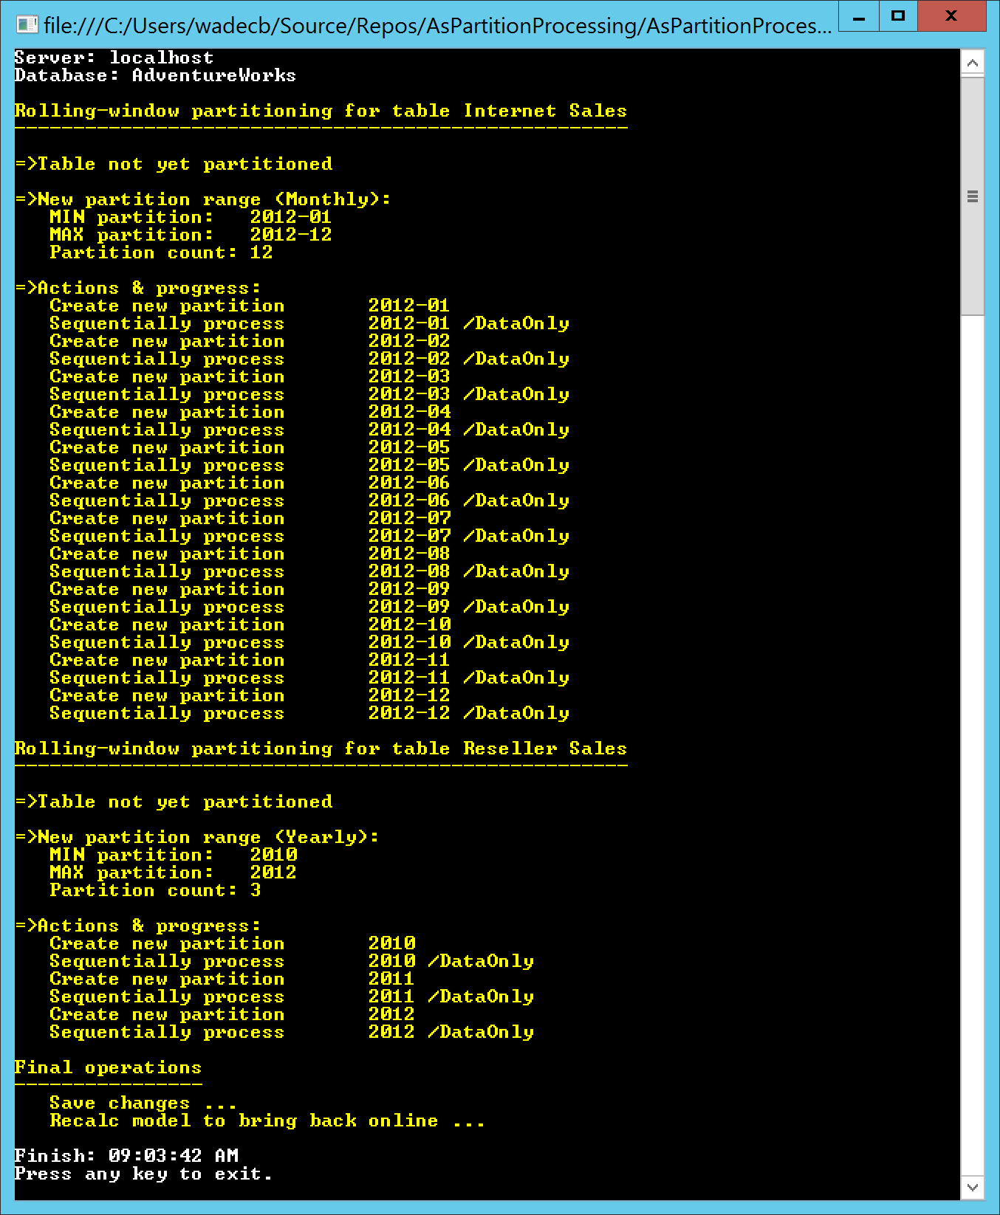

Use SSMS to inspect the partitions created. Partition source queries take the simple form:

SELECT * FROM <*source table*> WHERE <*partition filter*>

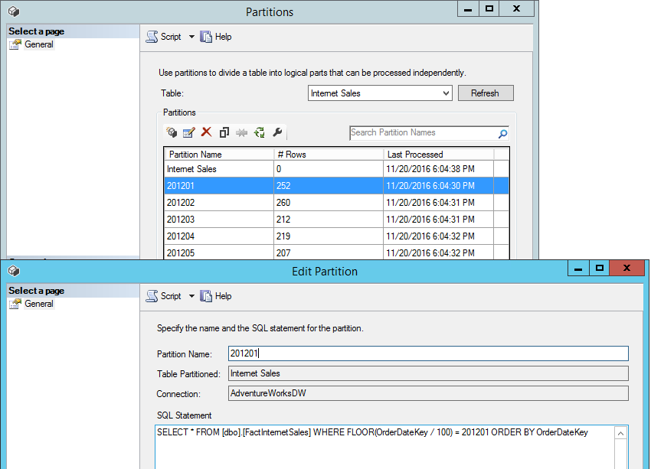

# Configuration & Logging Database

Typically, partitioning configuration and logging is done using a database. AsPartitionProcessing contains the CreateDatabaseObjects.sql script to create the necessary tables, and contains the methods for reading and writing to the database.

## Data model



### ModelConfiguration

Configuration information for an AS tabular model:

|  |  |
| --- | --- |
| Column | Description |
| ModelConfigurationID | Primary key. |
| AnalysisServicesServer | Name of the Analysis Services instance. Can be SSAS or an Azure AS URL. |
| AnalysisServicesDatabase | Name of the Analysis Services database. |
| InitialSetUp | True for initial set up to create partitions and process them sequentially.  False for incremental processing.  See Partitioning Strategy & Assumptions section above for more information. |
| IncrementalOnline | When initialSetUp=false, determines if processing is performed as an online operation, which can require more memory, but allows users to query the model during processing.  True to keep the model online (process Full).  See Partitioning Strategy & Assumptions section above for more information. |
| IntegratedAuth | Should always be set to true for SSAS implementations that will run under the current process account.  For Azure AS, normally set to false. |
| UserName | Only applies when integratedAuth=false. Can be used for Azure AD UPNs to connect to Azure AS. |
| Password | Only applies when integratedAuth=false. Can be used for Azure AD UPNs to connect to Azure AS. |
| MaxParallelism | Sets the maximum number of threads on which to run processing commands in parallel. -1 will not set the value. |
| CommitTimeout | Set to override of CommitTimeout server property value for the connection. -1 will not override; the server value will be used. |

### TableConfiguration

Configuration information for a table within an AS tabular model:

|  |  |
| --- | --- |
| Column | Description |
| TableConfigurationID | Primary key. |
| ModelConfigurationID | Foreign key to ModelConfiguration table. |
| AnalysisServicesTable | Name of the partitioned table in the tabular model. |
| DoNotProcess | Set to true to exclude the table from processing. This can be used to dynamically include/exclude tables. For example, near-realtime processing during the day requires only a few tables to be processed; overnight processing may process all tables. |

### PartitioningConfiguration

Configuration information for partitioning of a table within an AS tabular model.:

|  |  |
| --- | --- |
| Column | Description |
| PartitioningConfigurationID | Primary key. |
| TableConfigurationID | Foreign key to TableConfiguration table. |
| Granularity | Partition granularity, which can be Yearly, Monthly or Daily.  Daily = 0,  Monthly = 1,  Yearly = 2 |
| NumberOfPartitionsFull | Count of all partitions in the rolling window. For example, a rolling window of 10 years partitioned by month would require 120 partitions. |
| NumberOfPartitionsForIncrementalProcess | Count of *hot partitions* where the data can change. For example, it may be necessary to refresh the most recent 3 months of data every day. This only applies to the most recent partitions. |
| MaxDate | The maximum date that needs to be accounted for in the partitioning configuration. |
| SourceTableName | Name of the source table in the relational database. |
| SourcePartitionColumn | Name of the source column from the table in the relational database. |

### ProcessingLog

Log of partitioning execution:

|  |  |
| --- | --- |
| Column | Description |
| ProcessingLogID | Primary key. |
| ModelConfigurationID | Foreign key to ModelConfiguration table. |
| ExecutionID | GUID generated for the execution run. |
| LogDateTime | Date and time the message was logged. |
| Message | The log message. |

# Sample Configuration

The SampleConfiguration.sql script initializes the configuration for AdventureWorks. The script can be modified for use in customer implementations. Execute the script to initialize the database.

INSERT INTO [dbo].[ModelConfiguration]

VALUES(

1 --[ModelConfigurationID]

,'localhost' --[AnalysisServicesServer]

,'AdventureWorks' --[AnalysisServicesDatabase]

,1 --[InitialSetUp]

,1 --[IncrementalOnline]

,1 --[IntegratedAuth]

,-1 --[MaxParallelism]

,-1 --[CommitTimeout]

);

INSERT INTO [dbo].[TableConfiguration]

VALUES(

1 --[TableConfigurationID]

,1 --[ModelConfigurationID]

,'Internet Sales' --[AnalysisServicesTable]

,0 --[DoNotProcess]

),

(

2 --[TableConfigurationID]

,1 --[ModelConfigurationID]

,'Reseller Sales' --[AnalysisServicesTable]

,0 --[DoNotProcess]

);

INSERT INTO [dbo].[PartitioningConfiguration]

VALUES(

1 --[PartitioningConfigurationID]

,1 --[TableConfigurationID]

,1 --[Granularity] 1=Monthly

,12 --[NumberOfPartitionsFull]

,3 --[NumberOfPartitionsForIncrementalProcess]

,'2012-12-01' --[MaxDate]

,'[dbo].[FactInternetSales]'--[SourceTableName]

,'OrderDateKey' --[SourcePartitionColumn]

),

(

2 --[PartitioningConfigurationID]

,2 --[TableConfigurationID]

,2 --[Granularity] 2=Yearly

,3 --[NumberOfPartitionsFull]

,1 --[NumberOfPartitionsForIncrementalProcess]

,'2012-12-01' --[MaxDate]

,'[dbo].[FactResellerSales]'--[SourceTableName]

,'OrderDateKey' --[SourcePartitionColumn]

);

## Database connection info

Connection information to the configuration and logging database can be set in App.config in the userSettings section.

<userSettings>

<AsPartitionProcessing.SampleClient.Settings>

<setting name="ConfigServer" serializeAs="String">

<value>localhost</value>

</setting>

<setting name="ConfigDatabase" serializeAs="String">

<value>AsPartitionProcessing</value>

</setting>

<setting name="ConfigDatabaseIntegratedAuth" serializeAs="String">

<value>True</value>

</setting>

</AsPartitionProcessing.SampleClient.Settings>

</userSettings>

# Test Different Configurations

In this section, we will update the configuration, execute the sample, and view the log messages.

In Program.cs, change the ExecutionMode constant to be assigned InitializeFromDatabase.

const SampleExecutionMode ExecutionMode = SampleExecutionMode.InitializeFromDatabase;

Execute the SampleClient application, and the log query. If the SampleClient application was previously run from the Getting Started section, messages will show the partitions already exist and are processed.

In addition to the console output, the following query on the configuration and logging database shows the execution results. This can be used to test the different configurations below.

SELECT [Message]

FROM [dbo].[ProcessingLog]

WHERE ExecutionID =

( SELECT MAX([ExecutionID]) FROM [dbo].[ProcessingLog]

WHERE [LogDateTime] = (SELECT MAX([LogDateTime]) FROM [dbo].[ProcessingLog])

)

ORDER BY [LogDateTime]

## Incremental mode

Execute the following UPDATE statement to switch to incremental mode:

UPDATE [dbo].[ModelConfiguration] SET [InitialSetUp] = 0

Execute SampleClient application, and the log query. The following results should be shown. Only the specified number of most recent partitions are processed as an online operation.

Start: 12:41:02 PM

Server: localhost

Database: AdventureWorks

Rolling-window partitioning for table Internet Sales

----------------------------------------------------

=>Current partition range (Monthly):

MIN partition: 2012-01

MAX partition: 2012-12

Partition count: 12

=>New partition range (Monthly):

MIN partition: 2012-01

MAX partition: 2012-12

Partition count: 12

=>Actions & progress:

Parallel process partition 2012-10 /Full

Parallel process partition 2012-11 /Full

Parallel process partition 2012-12 /Full

Rolling-window partitioning for table Reseller Sales

----------------------------------------------------

=>Current partition range (Yearly):

MIN partition: 2010

MAX partition: 2012

Partition count: 3

=>New partition range (Yearly):

MIN partition: 2010

MAX partition: 2012

Partition count: 3

=>Actions & progress:

Parallel process partition 2012 /Full

Final operations

----------------

Save changes ...

Finish: 12:41:07 PM

## Increment partition range

Execute the following UPDATE statement to increment the partition range by one period.

UPDATE [dbo].[PartitioningConfiguration] SET [MaxDate] = '2013-01-01'

Execute SampleClient application, and the log query. The following results should be shown. The oldest partition is removed from both tables, a new one is added and the most recent partitions are processed.

Start: 12:47:26 PM

Server: localhost

Database: AdventureWorks

Rolling-window partitioning for table Internet Sales

----------------------------------------------------

=>Current partition range (Monthly):

MIN partition: 2012-01

MAX partition: 2012-12

Partition count: 12

=>New partition range (Monthly):

MIN partition: 2012-02

MAX partition: 2013-01

Partition count: 12

=>Actions & progress:

Remove old partition 2012-01

Parallel process partition 2012-11 /Full

Parallel process partition 2012-12 /Full

Create new partition 2013-01

Parallel process partition 2013-01 /Full

Rolling-window partitioning for table Reseller Sales

----------------------------------------------------

=>Current partition range (Yearly):

MIN partition: 2010

MAX partition: 2012

Partition count: 3

=>New partition range (Yearly):

MIN partition: 2011

MAX partition: 2013

Partition count: 3

=>Actions & progress:

Remove old partition 2010

Create new partition 2013

Parallel process partition 2013 /Full

Final operations

----------------

Save changes ...

Finish: 12:47:34 PM

## Offline processing

Execute the following UPDATE statement to perform offline processing and potentially use less memory.

UPDATE [dbo].[ModelConfiguration] SET [IncrementalOnline] = 0

Execute SampleClient application, and the log query. The following results should be shown. The partitions are processed using RefreshType of DataOnly, and a Recalc operation is performed to bring the model back online.

Start: 12:53:19 PM

Server: localhost

Database: AdventureWorks

Rolling-window partitioning for table Internet Sales

----------------------------------------------------

=>Current partition range (Monthly):

MIN partition: 2012-02

MAX partition: 2013-01

Partition count: 12

=>New partition range (Monthly):

MIN partition: 2012-02

MAX partition: 2013-01

Partition count: 12

=>Actions & progress:

Parallel process partition 2012-11 /DataOnly

Parallel process partition 2012-12 /DataOnly

Parallel process partition 2013-01 /DataOnly

Rolling-window partitioning for table Reseller Sales

----------------------------------------------------

=>Current partition range (Yearly):

MIN partition: 2011

MAX partition: 2013

Partition count: 3

=>New partition range (Yearly):

MIN partition: 2011

MAX partition: 2013

Partition count: 3

=>Actions & progress:

Parallel process partition 2013 /DataOnly

Final operations

----------------

Save changes ...

Recalc model to bring back online ...

Finish: 12:53:27 PM

## Non-partitioned table processing & table omission

Execute the following INSERT statement to create table configurations for the Customer, Product and Sales Quota tables.

INSERT INTO [dbo].[TableConfiguration]

VALUES(

3 --[TableConfigurationID]

,1 --[ModelConfigurationID]

,'Customer' --[AnalysisServicesTable]

,0 --[DoNotProcess]

),

(

4 --[TableConfigurationID]

,1 --[ModelConfigurationID]

,'Product' --[AnalysisServicesTable]

,0 --[DoNotProcess]

),

(

5 --[TableConfigurationID]

,1 --[ModelConfigurationID]

,'Sales Quota' --[AnalysisServicesTable]

,1 --[DoNotProcess]

);

Sales Quota has DoNotProcess equal to 1, so it will be excluded from processing. This flag can be used to dynamically include and exclude tables. For example, certain tables can be processed during the day for near-real time requirements and other tables processed overnight.

The Customer and Product tables will be processed. They do not have entries in the PartitioningConfiguration table, so they will be treated as non-partitioned tables and processed at the table level.

Other tables in the model that do not have table configuration entries are omitted from processing. Some tables may have no ongoing processing requirements. For example, the date-dimension table and categorical dimension tables typically have no need to be processed daily, so they can be left out altogether.

Execute SampleClient application, and the log query. The following results should be shown. The Customer and Product non-partitioned tables are processed.

Start: 08:55:05 PM

Server: localhost

Database: AdventureWorks

Rolling-window partitioning for table Internet Sales

----------------------------------------------------

=>Current partition range (Monthly):

MIN partition: 2012-02

MAX partition: 2013-01

Partition count: 12

=>New partition range (Monthly):

MIN partition: 2012-02

MAX partition: 2013-01

Partition count: 12

=>Actions & progress:

Parallel process partition 2012-11 /DataOnly

Parallel process partition 2012-12 /DataOnly

Parallel process partition 2013-01 /DataOnly

Save changes for table Internet Sales ...

Rolling-window partitioning for table Reseller Sales

----------------------------------------------------

=>Current partition range (Yearly):

MIN partition: 2011

MAX partition: 2013

Partition count: 3

=>New partition range (Yearly):

MIN partition: 2011

MAX partition: 2013

Partition count: 3

=>Actions & progress:

Parallel process partition 2013 /DataOnly

Save changes for table Reseller Sales ...

Non-partitioned processing for table Customer

---------------------------------------------

Process table Customer /DataOnly

Non-partitioned processing for table Product

--------------------------------------------

Process table Product /DataOnly

Final operations

----------------

Save changes ...

Recalc model to bring back online ...

Finish: 08:55:17 PM

## Merging partitions

Merging of partitions may be useful in mixed-granularity scenarios. For example, merging historical days into a month, or merging historical months into a year. Care must be taken when merging partitions to ensure it is done correctly. Once merged, it is not possible to unmerge.

In Program.cs, change the ExecutionMode constant to be assigned MergePartitions.

const SampleExecutionMode ExecutionMode = SampleExecutionMode.MergePartitions;

Execute SampleClient application, and the log query. The following results should be shown. The months in 2012 are merged into the year 2012.

Merge partitions into 2012 for table Internet Sales

---------------------------------------------------

=>Actions & progress:

Create new merged partition 2012 for table Internet Sales

Partition 201202 to be merged into 2012

Partition 201203 to be merged into 2012

Partition 201204 to be merged into 2012

Partition 201205 to be merged into 2012

Partition 201206 to be merged into 2012

Partition 201207 to be merged into 2012

Partition 201208 to be merged into 2012

Partition 201209 to be merged into 2012

Partition 201210 to be merged into 2012

Partition 201211 to be merged into 2012

Partition 201212 to be merged into 2012

Save changes for table Internet Sales ...

Finish: 10:03:38 PM

Inspect the new partition structure in SSMS.

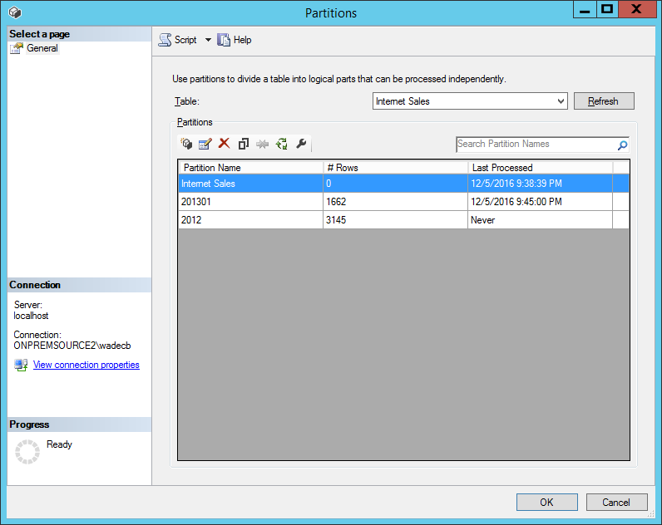

## Mixed granularity configurations

For mixed granularity scenarios, it may be necessary to set up multiple configurations for a single table. This allows automated removal of old partitions – at different granularities – that fall out of range. Care must be taken to ensure multi-grain configurations are set correctly to avoid integrity issues.

In Program.cs, change the ExecutionMode constant back to InitializeFromDatabase.

const SampleExecutionMode ExecutionMode = SampleExecutionMode.InitializeFromDatabase;

Execute the following INSERT and UPDATE statements to configure mixed granularity for the Internet Sales table. The yearly configuration covers 2012; the monthly one covers January through March 2013. There is no overlap between the date ranges at different granularities.

--Insert yearly configuration for Internet Sales

INSERT INTO [dbo].[PartitioningConfiguration]

VALUES

(

3 --[PartitioningConfigurationID]

,1 --[TableConfigurationID]

,2 --[Granularity] 2=Yearly

,1 --[NumberOfPartitionsFull]

,1 --[NumberOfPartitionsForIncrementalProcess]

,'2012-12-31' --[MaxDate]

,'[dbo].[FactInternetSales]'--[SourceTableName]

,'OrderDateKey' --[SourcePartitionColumn]

);

--Update monthly configuration for Internet Sales

UPDATE dbo.[PartitioningConfiguration] SET

NumberOfPartitionsFull = 3,

NumberOfPartitionsForIncrementalProcess = 3,

MaxDate = '2013-03-01'

WHERE PartitioningConfigurationID = 1;

Execute SampleClient application, and the log query. The following results should be shown. Internet Sales has 3 partitions at the month level, and 1 at the year level.

Start: 11:24:05 PM

Server: localhost

Database: AdventureWorks

Rolling-window partitioning for table Internet Sales

----------------------------------------------------

=>Current partition range (Yearly):

MIN partition: 2012

MAX partition: 2012

Partition count: 1

=>New partition range (Yearly):

MIN partition: 2012

MAX partition: 2012

Partition count: 1

=>Actions & progress:

Parallel process partition 2012 /DataOnly

Rolling-window partitioning for table Internet Sales

----------------------------------------------------

=>Current partition range (Monthly):

MIN partition: 2013-01

MAX partition: 2013-01

Partition count: 1

=>New partition range (Monthly):

MIN partition: 2013-01

MAX partition: 2013-03

Partition count: 3

=>Actions & progress:

Parallel process partition 2013-01 /DataOnly

Create new partition 2013-02

Parallel process partition 2013-02 /DataOnly

Create new partition 2013-03

Parallel process partition 2013-03 /DataOnly

Rolling-window partitioning for table Reseller Sales

----------------------------------------------------

=>Current partition range (Yearly):

MIN partition: 2011

MAX partition: 2013

Partition count: 3

=>New partition range (Yearly):

MIN partition: 2011

MAX partition: 2013

Partition count: 3

=>Actions & progress:

Parallel process partition 2013 /DataOnly

Non-partitioned processing for table Customer

---------------------------------------------

Process table Customer /DataOnly

Non-partitioned processing for table Product

--------------------------------------------

Process table Product /DataOnly

Final operations

----------------

Save changes ...

Recalc model to bring back online ...

Finish: 11:24:15 PM

## Validation of date ranges for mixed granularity configurations

It is important to ensure there are no overlapping date ranges at different granularities for the same table. AsPartitionProcessing performs some validation to avoid this.

Execute the following UPDATE statement to extend the yearly configuration range to include 2012 and 2013. There is now an overlap with the monthly configuration range, which covers January through March of 2013.

--Update yearly configuration for Internet Sales

UPDATE dbo.[PartitioningConfiguration] SET

NumberOfPartitionsFull = 2,

MaxDate = '2013-01-01'

WHERE PartitioningConfigurationID = 3;

Execute SampleClient application, and the log query. The following results should be shown. An exception was raised due to overlapping date ranges in the same table.

Start: 11:51:22 PM

Server: localhost

Database: AdventureWorks

Exception occurred: 11:51:48 PM

Exception message: Table Internet Sales contains partitioning configurations with

overlapping date ranges, which is not allowed. Yearly upper boundary is 2013-12-31;

Monthly lower boundary is 2013-01-01.

Execute the following UPDATE statement to remove the overlap.

--Update yearly configuration for Internet Sales

UPDATE dbo.[PartitioningConfiguration] SET

NumberOfPartitionsFull = 1,

MaxDate = '2012-01-01'

WHERE PartitioningConfigurationID = 3;

# Other Considerations

## Cloud architecture

AsPartitionProcessing can be used in cloud PaaS/SaaS architectures. The following diagram shows an example of such an architecture.

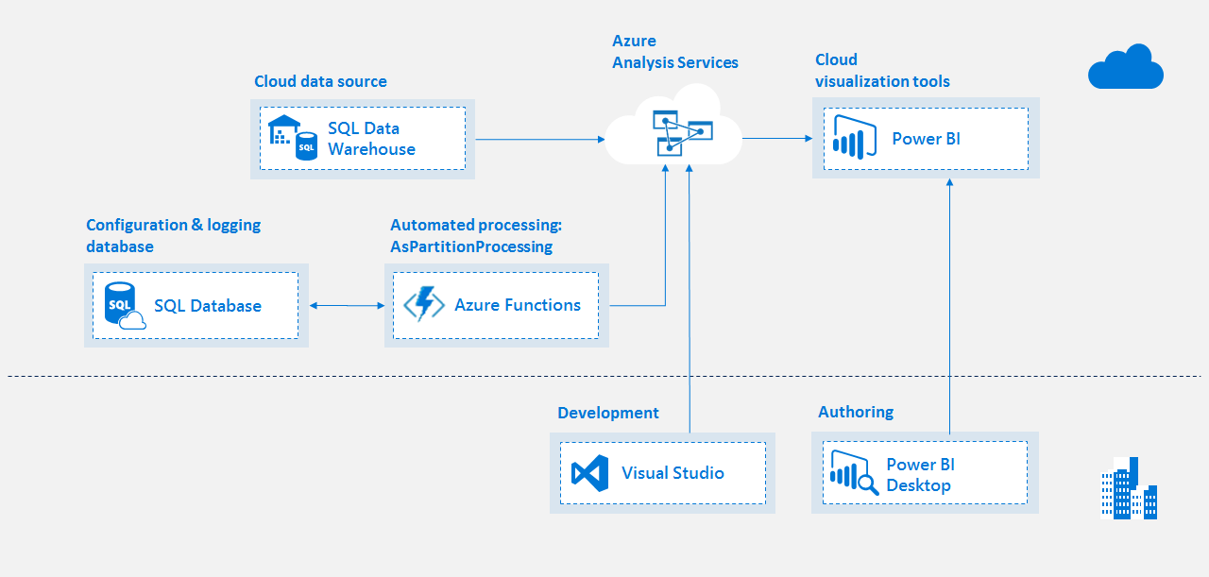

[Azure SQL Database](https://azure.microsoft.com/en-us/services/sql-database/) is used for the configuration and logging database.

[Azure Functions](https://azure.microsoft.com/en-us/services/functions/) is used with a reference to the AsPartitionProcessing class library. Execution can be triggered in various ways. The following list is just a sample of the options available with Azure Functions. Detailed discussion on the pros and cons of each option is outside the scope of this document.

* Scheduled using a Timer function CRON expression. In this case, it is not necessary to set up a separate scheduling system.
* Using a webhook request for a WebHook function, or an HTTP request for an HttpTrigger function. This allows integration with existing scheduling systems that can call a URL.
* Triggered from Azure Queue using built-in integration points in Azure Functions.

It is necessary to upload the TOM and AsPartitionProcessing DLLs to Azure Functions. See [here](https://docs.microsoft.com/en-us/azure/azure-functions/functions-reference-csharp#referencing-external-assemblies) for more information on how to do this. The TOM DLLs must be the minimum version to work with Azure Analysis Services, and are available by installing the client libraries from [here](https://docs.microsoft.com/en-us/azure/analysis-services/analysis-services-connect#client-libraries). The following screenshot shows the Azure Functions editor with the DLLs uploaded to the bin folder and referenced at the top.

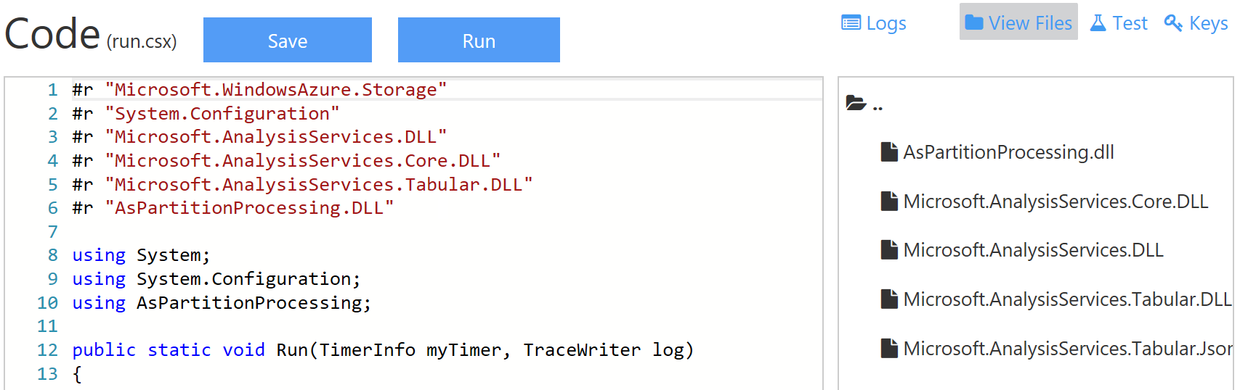

With the necessary class-library references in place, the function body can be written using SampleClient as a template. Again, PerformProcessing is the key method.

PartitionProcessor.PerformProcessing(modelConfig, ConfigDatabaseHelper.LogMessage);

The modelConfig parameter can be initialized in a similar way to the SampleClient application. Information that SampleClient stores in App.config for the configuration and logging database can be stored using built-in Azure Functions application settings.

It is not necessary for the LogMessage delegate parameter to refer to a method defined in Azure Functions if there are no custom logging requirements. Instead the ConfigDatabaseHelper.LogMessage method can be referenced directly as it has the required signature.

## Custom logging

The LogMessage method in Program.cs is passed as a delegate into the PerformProcessing method, so it can easily be changed for custom logging requirements.

private static void LogMessage(string message, ModelConfiguration partitionedModel)

{

//Can provide custom logging code here

...

## Fragmentation

Partitioned tables may suffer from fragmentation over time. When a partition is removed from a table, the table dictionary entries are retained despite having no rows of data. Defragmentation removes the unused dictionary entries. It is not necessary to perform defragmentation on non-partitioned tables because they are processed at the table level. Defragmentation of large tables can be an expensive, sometimes time-consuming, operation. Further information on defragmentation is available [here](http://sqlblog.com/blogs/marco_russo/archive/2013/03/13/cost-of-process-defrag-in-analysis-services-tabular-ssas-tabular.aspx) and [here](https://cathydumas.com/2012/04/30/process-defrag/). Dictionary and table size can be monitored using community tools such as [VertiPaq Analyzer](http://www.sqlbi.com/tools/vertipaq-analyzer/) and [SSAS Memory Usage Report](http://www.kasperonbi.com/new-ssas-memory-usage-report-using-power-bi/).

In Program.cs, change the ExecutionMode constant to be assigned DefragPartitionedTables.

const SampleExecutionMode ExecutionMode = SampleExecutionMode.DefragPartitionedTables;

Execute SampleClient application, and the log query. The following results should be shown. The tables with partitioning configurations are defragmented.

Start: 12:30:15 PM

Server: localhost

Database: AdventureWorks

Defrag partitioned tables in database AdventureWorks

----------------------------------------------------

=>Actions & progress:

Defrag table Internet Sales ...

Defrag table Reseller Sales ...

Finish: 12:30:17 PM

## Locking and blocking

Detailed discussion around locking causes and diagnosis is out of the scope of this document. However, it is worth pointing out that queries take Commit_Read locks, which can block Commit_Write locks. Commit_Write locks are required by processing operations. Therefore, long-running queries can block processing operations. Normally, the processing operation will wait for the period set in the ForceCommitTimeout server property; the default is 30 seconds. If the query still hasn’t finished, the query will fail with the following error and the processing operation will then continue.

Executing the query ...

The operation was cancelled because of locking conflicts.

In some cases, it may be beneficial to prioritize queries over processing operations. For example, when performing small, near-real time refreshes at regular intervals during the day. If many users are using the system, it is often preferable to allow queries to run to completion and fail the processing operation instead, especially if it will run again after a short interval anyway.

This can be achieved using the CommitTimeout property. CommitTimeout is a server property to specify how long the server will wait to acquire write locks (typically for processing operations). The default value is zero (0), meaning the server will wait indefinitely. In practice, it does not normally wait more than 30 seconds because ForceCommitTimeout will kick in and fail long-running queries (as explained above).

CommitTimeout can be overridden for a connection. With ForceCommitTimeout set to the default of 30 seconds and CommitTimeout set to 20 seconds, processing operations will wait 20 seconds to acquire write locks. If still blocked by a long-running query, the processing operation will fail, allowing the query to run to completion.

In Program.cs, change the ExecutionMode constant to be assigned InitializeFromDatabase.

const SampleExecutionMode ExecutionMode = SampleExecutionMode.InitializeFromDatabase;

Execute the following UPDATE statement to set CommitTimeout to 20 seconds (20,000 miliseconds).

UPDATE [dbo].[ModelConfiguration] SET [CommitTimeout] = 20000

If you now start execution of a long-running query (over 20 seconds) just before execution of the SampleClient application, the processing operation should fail with the following error message.

Exception message: Failed to save modifications to the server. Error returned: 'The

lock operation timed out'.

*Note: commit transactions have been optimized considerably for tabular models in SQL Server 2016 normally resulting in shorter Commit_Write locks.*

## Parallelization of incremental processing

Incremental processing is submitted as a parallelized operation for all tables and partitions within a model. Parallelization can be reduced by setting the MaxConnections property on a data source. The default of 10 means that no more than 10 queries will be submitted to the source system at a time. This can be used to limit stress on source systems during processing.

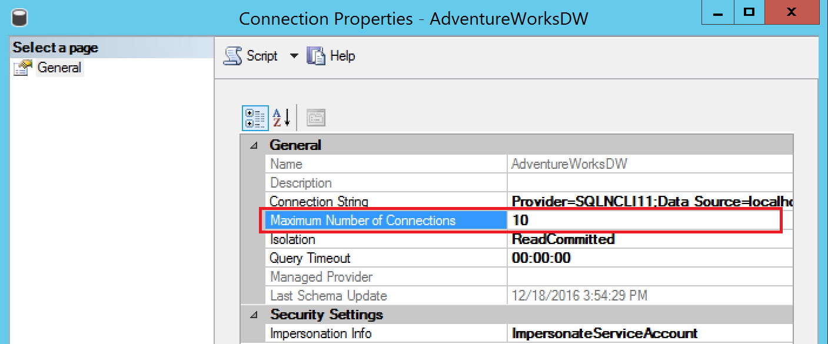

Within the constraints set by MaxConnections, Analysis Services will determine the number of processing threads based on the number of processors available.

Resource-constrained environments can further limit parallelization by setting the *MaxParallelism* property on the ModelConfiguration table. The impact of setting MaxParallelism is visible using the [SSAS performance counters](https://msdn.microsoft.com/en-us/library/hh230807.aspx?f=255&MSPPError=-2147217396#bkmk_Threads) in the Threads section such as *Processing pool busy non-I/O threads*.

## Model deployment

When deploying new versions of partitioned tabular models that already exist on the target environment, it is necessary to be aware of the partitioning process already in-place. As shown by this code sample, partitions are normally created and managed by a separate process. This means the version of the tabular model from source control does not contain the partitions. A simple deployment process such as right-click, Deploy from SSDT will lose the partitions and all the data within them. Tools that support deployment retaining partitions include [BISM Normalizer](https://marketplace.visualstudio.com/items?itemName=ChristianWade.BISMNormalizer3) and the [Analysis Services Deployment Wizard](https://msdn.microsoft.com/library/ms176121.aspx). Both these tools support command-line execution for automated deployment. Detailed discussion on this topic including the pros and cons of these tools is outside the scope of this document.

## AsPerfMon

Another code sample that may be useful in conjunction with AsPartitionProcessing is the AsPerfMon tool, which is available [here](https://github.com/Microsoft/Analysis-Services/tree/master/AsPerfMon). AsPerfMon can be used to check real-time memory usage during processing. It splits memory usage by database, which is informative when multiple databases share the same server.



This is useful for Azure AS since you can’t use Task Manager or create Performance Monitor counters. Similar functionality is provided by the Metrics section in the control blade for an Azure AS server in the Azure Portal. By using Metrics, you can check usage for the past day or week. AsPerfMon is for real-time monitoring during processing.